

Contents:
Introduction
Existing System
Proposed System
Software Requirements
Hardware Requirements
Architectural diagram
Data flow diagram
Table Design
Data Dictionary
Relational diagram
Program design
Testing
Conclusion
References
Source code
Screen shot

Introduction:
Currency exchange rate forecasting is the process of predicting future exchange rates. This is a complex task, as there are many factors that can affect exchange rates, including economic conditions, political events, and investor sentiment.
Time series forecasting is a statistical method that can be used to predict future values based on historical data. This method is often used for currency exchange rate forecasting, as it can capture the long-term trends and short-term fluctuations in exchange rates.
SystemExisting:

The existing system for currency exchange rate forecasting is based on a manual process. Analysts collect historical data and use statistical methods to forecast future exchange rates. This process is time-consuming and error-prone

Proposed System:

The proposed system for currency exchange rate forecasting will use a machine learning algorithm to predict future exchange rates. The algorithm will be trained on historical data and will be able to learn the patterns in exchange rate movements. This will allow the system to make more accurate predictions than the existing system.
Software Requirements:

=>8GB Ram
=>256 internal memory
=>intel processor

Hardware Requirements:

=>window os
=>Python Gui or Anaconda navigator(Anaconda jupyter)

Architectural Diagram:

The architectural diagram for the proposed system is shown below. The system will consist of a data collection module, a machine learning module, and a forecasting module.

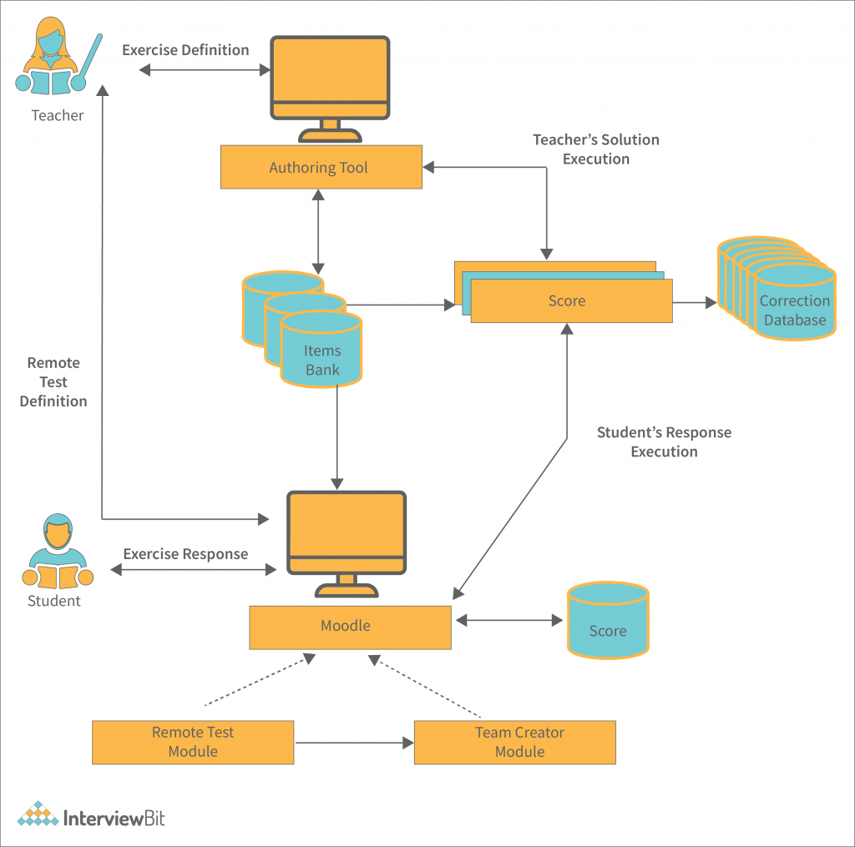
The data collection module will collect historical exchange rate data from a variety of sources. The machine learning module will use the historical data to train the algorithm. The forecasting module will use the algorithm to make predictions about future exchange rates.

Data flow diagram:

The data flow diagram for the proposed system is shown below. The data flow diagram shows how the data will flow through the system.

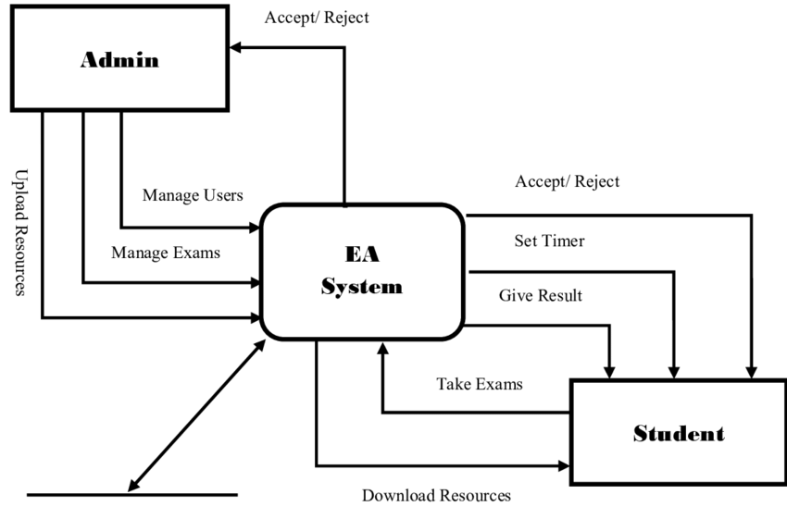
The data will be collected from a variety of sources, including financial websites, news websites, and government websites. The data will then be stored in a database. The machine learning algorithm will use the data in the database to make predictions about future exchange rates.

Data Design:

The table design for the database is shown below. The database will contain the following tables:
- Exchange_Rates table: This table will store the historical exchange rate data.
- Forecasts table: This table will store the predictions made by the machine learning algorithm.
Data Dictionary:
The data dictionary for the database is shown below. The data dictionary defines the fields in the database.

Exchange_Rates table:
  - Date (date): The date of the exchange rate.
  - Price (float): The exchange rate price.
Forecasts table:
  - Date (date): The date of the forecast.
  - Price (float): The predicted exchange rate price.
Relational Diagram:
The relational diagram for the database is shown below. The relational diagram shows the relationships between the tables in the database.

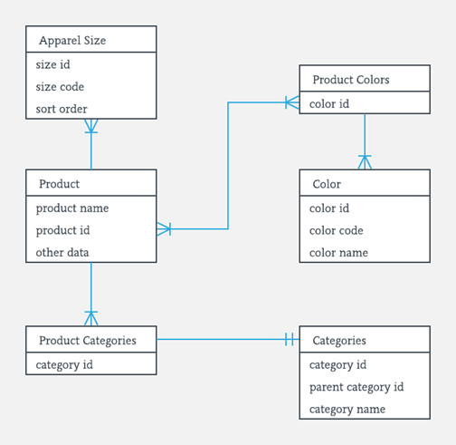
The Exchange_Rates table is related to the Forecasts table by the Date field. This means that each forecast in the Forecasts table is associated with an exchange rate in the Exchange_Rates table.
Program Design:

The program design for the proposed system is shown below. The program consists of the following modules:
- Data collection module
- Data analysis module
- Forecasting module
The data collection module collects data from a variety of sources. The data analysis module analyses the data and identifies patterns. The forecasting module uses the patterns identified by the data analysis module to forecast future currency exchange rates.
Testing:
The proposed system will be tested using the following methods:
- Unit testing
- Integration testing
- System testing
Unit testing will be used to test individual modules in the system. Integration testing will be used to test the interactions between modules in the system. System testing will be used to test the entire system.
Conclusion:

The proposed system will use time series analysis to forecast currency exchange rates. The system will be more accurate than the existing system based on fundamental analysis. The system will be tested using a variety of methods. The system will be implemented using a variety of programming languages.

Reference:
=>From the above project we can predict the currency exchange by using time series algorithm
=>we can are taking the data from database and use Date and Price by using these we can predict the currency exchange
=>we have implementing the time series algorithm to predict the currency exchange
=>After the model creation we have to deploy the model into server

